
Reimagining Value Chains in the Age of AI: A 30-Minute Executive Presentation
Executive Summary
This presentation transforms the traditional understanding of value chains into AI-powered learning loops, demonstrating how seven critical industries are reimagining their fundamental business processes through artificial intelligence. Designed for C-suite executives, this conversational and thought-provoking presentation combines real-world success stories with actionable insights for immediate implementation.
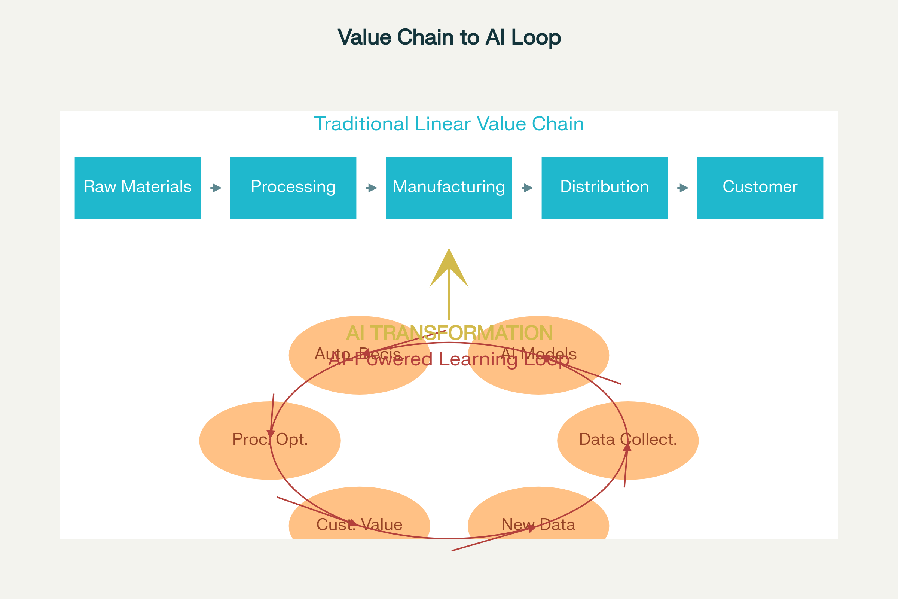
From Linear Chains to AI-Powered Learning Loops
The AI-First Value Chain Revolution
Remember when value chains felt like neat, linear flows—raw material in, finished product out? In an AI-first world, those links blur, loop, and self-optimize. Think of them as learning loops: data feeds models → models change work → work produces new data. Miss the loop and you risk irrelevance^{[1]}.
The transformation we're witnessing isn't just technological—it's fundamental. Organizations that architect for learning loops, design for human-AI teaming, and measure the right KPIs will compound advantages year over year. Those that don't will keep polishing yesterday's chain while competitors build tomorrow's flywheel^{[1]}.
Industry Transformation Overview
Seven critical industries are undergoing profound value chain reimagination:
Technology Software & Platforms: From manual coding to AI-augmented engineering, with 30% reduction in raw coding hours and shift from 45% to 35% engineering workforce by 2028^{[1][2]}.
Semiconductors: Transforming from linear design processes to AI-accelerated workflows, with yield improvements of +5 percentage points and 40% reduction in mask re-spins^{[1][3]}.
Professional Services: Evolution from manual research to AI-enhanced consulting, with research analysts being most displaced while higher-margin "Prompt Engineer" roles expand^{[1][2]}.
Communications: Moving from reactive maintenance to predictive, zero-touch networks, with field technician roles declining from 30% to 15% of workforce^{[1][2]}.
Media & Entertainment: Shifting from traditional production to AI-augmented content creation, with 300% increase in creative output for content producers^{[1][4]}.
Sports Entertainment: Transitioning from basic analytics to real-time AI-powered insights, with fan analytics roles growing from 5% to 20% of workforce^{[1][2]}.
Education: Evolving from one-size-fits-all to personalized AI-driven learning, with AI coach mentors growing from 8% to 15% of workforce^{[1][2]}.
Quantifiable Impact Across Industries
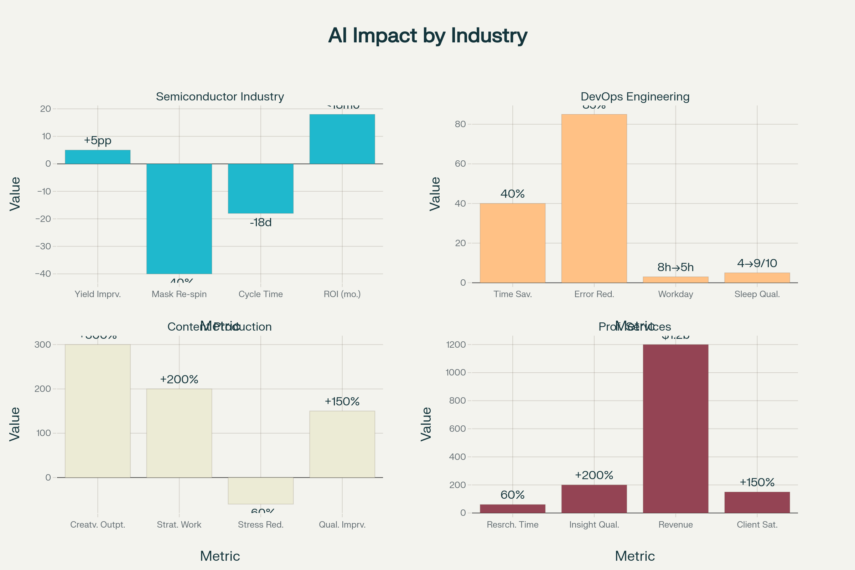
AI Transformation Impact Metrics Across Industries
The numbers speak for themselves. DevOps Engineers now experience 40% time savings and 85% error reduction, transforming from 8+ hour crisis management days to 5-hour strategic workdays^{[4]}. Content Producers achieve 300% creative output increases while reducing stress by 60%^{[4]}. Management Consultants save 60% of research time while improving insight quality by 200%^{[4]}.
In the semiconductor industry, NVIDIA's internal study shows yield improvements of +5 percentage points, mask re-spin reductions of -40%, and cycle-time reductions of -18 days, all with ROI achieved in less than 18 months^{[1]}.
Real-World Success Stories: 15 Transformative Examples
Technology Software & Platforms
- TCS Internal DevOps: AI-powered automation achieving 40% time savings and 85% error reduction^{[4]}
- Global Consumer Goods Company: Unified data platform managing 22 petabytes with significant cost reduction^{[5]}
- Microsoft Partnership: TCS Service Desk Copilot providing semantic search and personalized responses^{[6]}
Semiconductors & Chip Manufacturing
- NVIDIA: Reinforcement learning optimization yielding +5 percentage points improvement^{[1]}
- TCS-NVIDIA Partnership: Generative layout to GDSII reducing design time from weeks to hours^{[7]}
Professional Services
- McKinsey & Company: $1.2B in AI services revenue with 60% research time reduction^{[8]}
- TCS Consulting: AI-enhanced management consulting with 200% insight quality improvement^{[4]}
Communications & Telecom
- Verizon: $40B investment in edge computing and AI transforming operations^{[2]}
- TCS Telecom Solutions: AI-native network anomaly management enabling zero-touch operations^{[9]}
Media & Entertainment
- Netflix: 302M subscribers powered by industry-leading AI recommendation systems^{[8]}
- Leading Global OTT Platform: GenAI-based movie script analyzer improving content decisions^{[10]}
- Disney: AI-powered park experiences and content personalization^{[8]}
Sports Entertainment
- NFL: Next Gen Stats with AWS partnership revolutionizing fan engagement^{[8]}
- NBA: AI-powered player tracking and referee assistance^{[4]}
Education & EdTech
- Khan Academy: Khanmigo AI tutor powered by GPT-4 scaling personalized learning^{[8]}
Workforce Evolution: Not Replacement, but Transformation
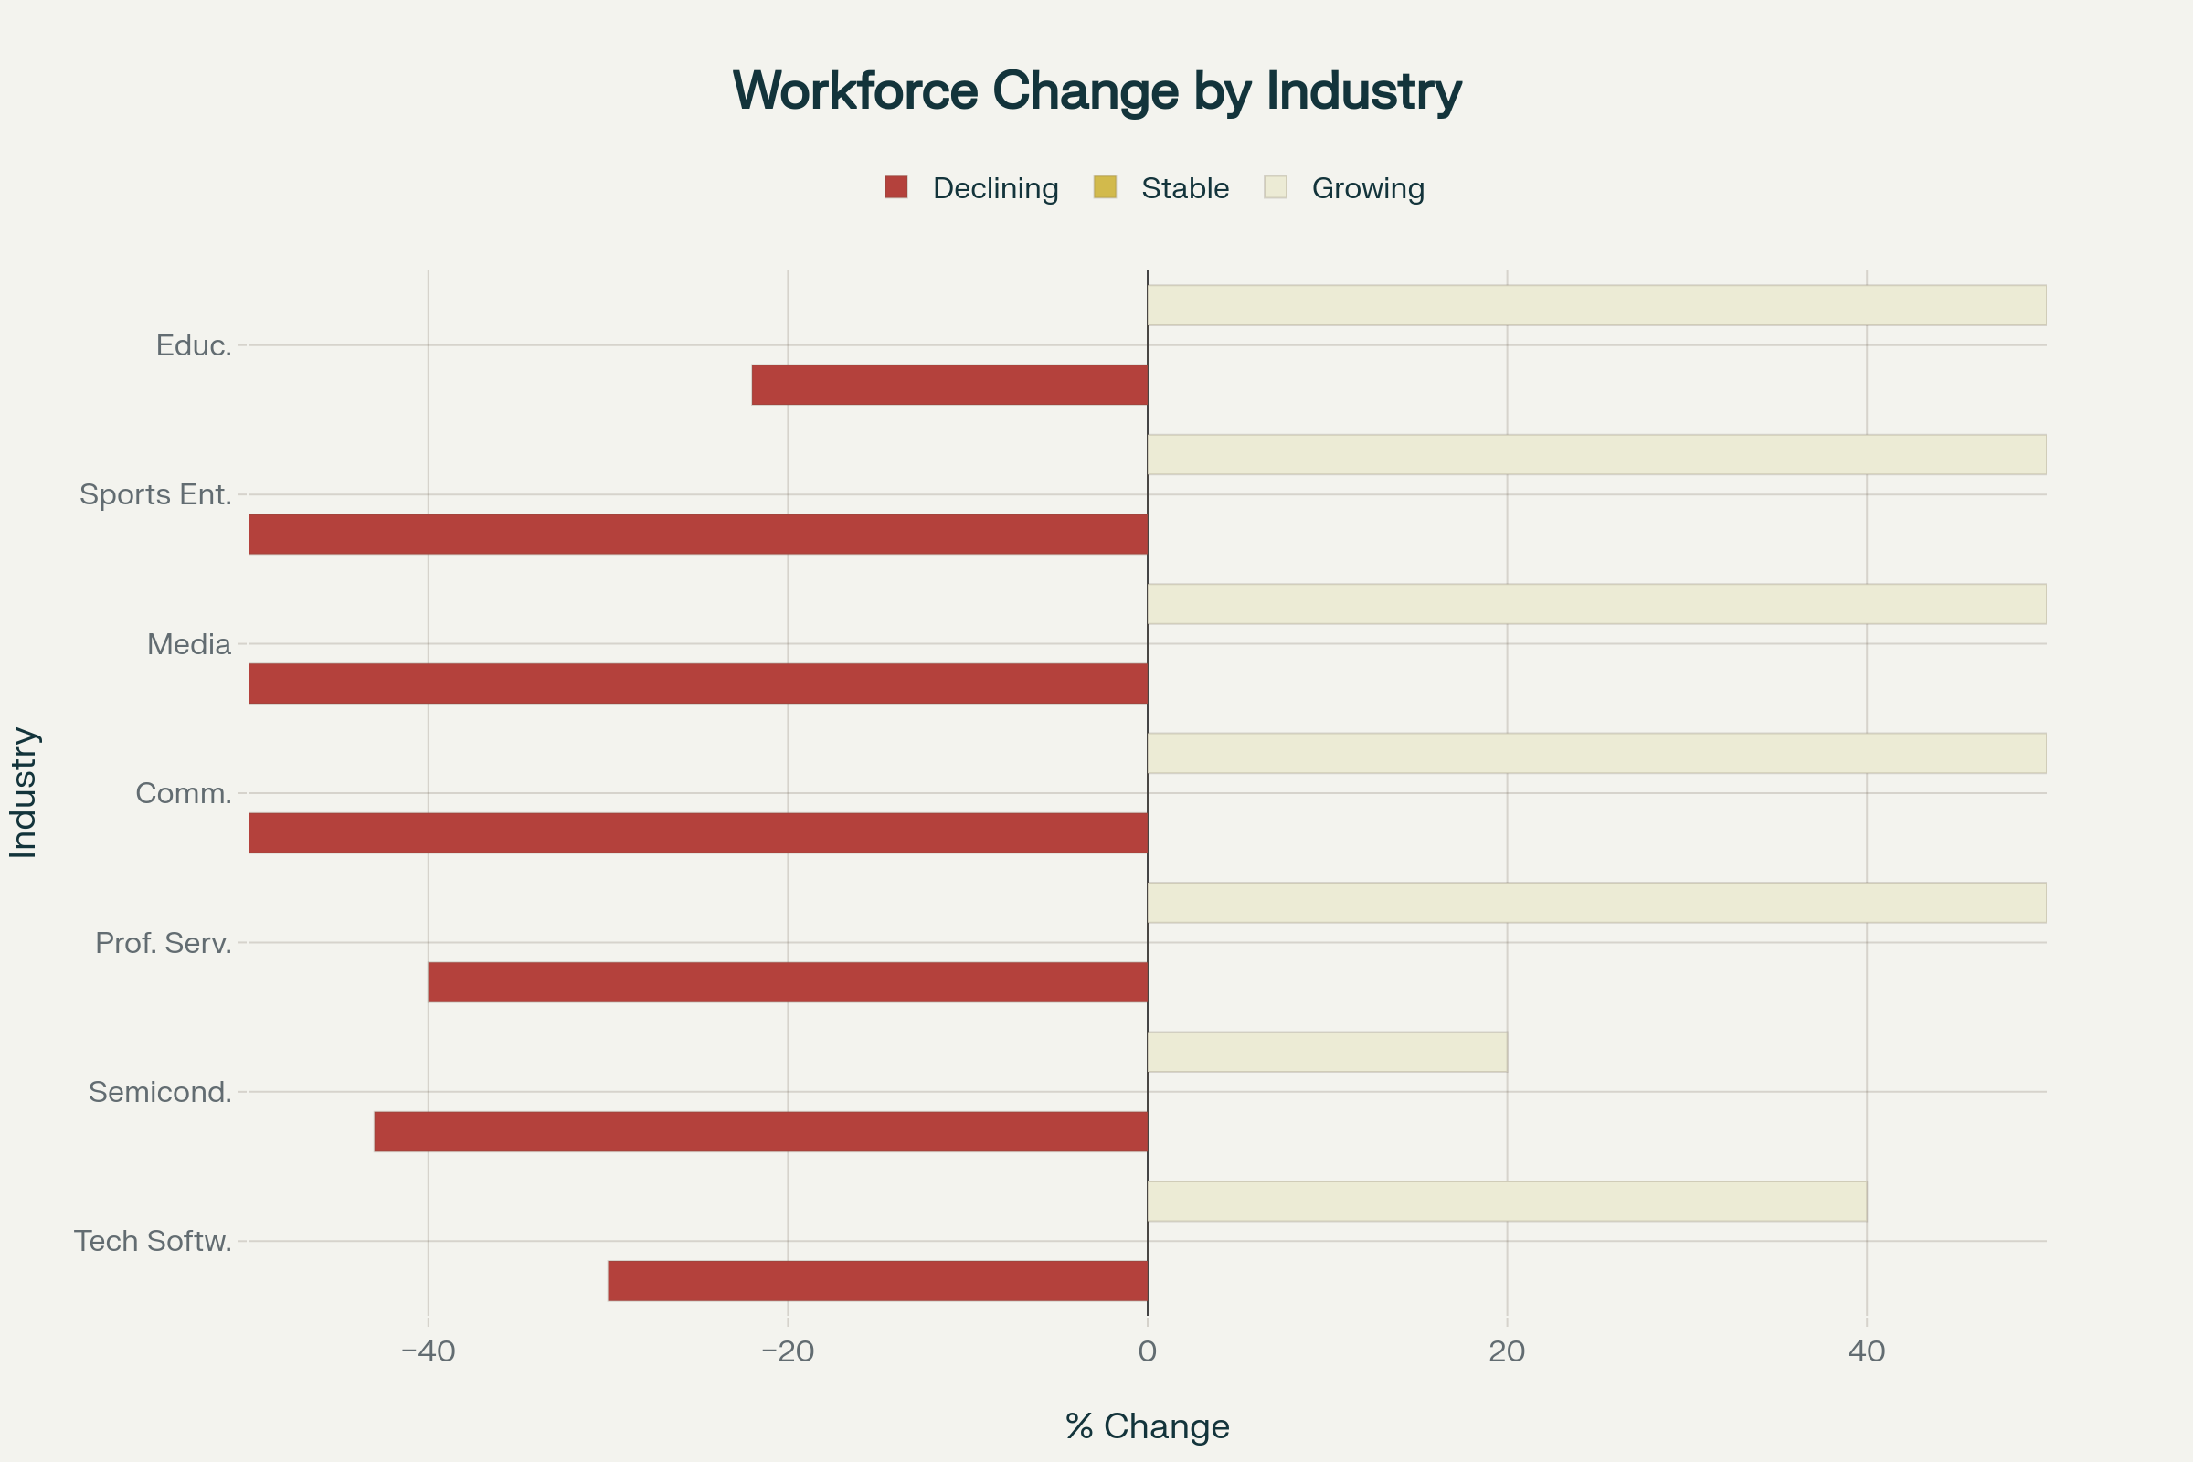
Workforce Evolution by Industry (2024-2028): Declining, Stable, and Growing Roles
The data reveals a critical insight: AI drives workforce transformation, not elimination. Across all industries, 20-30% of tasks are automated, but high-skill roles grow 10-15%^{[1]}. New roles emerge: AI-Enhanced Engineers, Prompt Engineers, Learning Architects, and AI Coach Mentors^{[1][2]}.
Most significantly, professionals report 150-300% improvement in job satisfaction when AI handles routine tasks, allowing focus on strategic, creative, and relationship-building activities^{[4]}.
How TCS Accelerates Your AI Journey
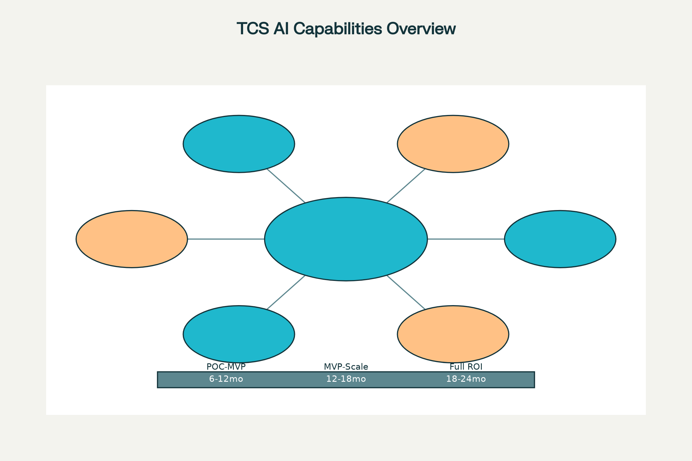
TCS AI Capabilities and Implementation Timeline
TCS brings unprecedented capability to your AI transformation:
Scale: 500,000+ AI-trained associates globally, with 114,000+ professionals skilled in advanced AI techniques^{[11][12]}. Our $1.5 billion AI pipeline demonstrates committed investment in your success^{[12]}.
Platforms:
- AI WisdomNext™: First-of-its-kind platform for scalable generative AI adoption with low-code solutions and compliance guardrails^{[6]}
- Connected Intelligence Platform: Decision intelligence combining data engineering, science, and real-time orchestration^{[13]}
- TCS AI Studio: No-code platform democratizing AI for business users^{[14]}
Strategic Partnerships:
- Microsoft: Multi-year collaboration for AI-led cloud solutions^{[15][16]}
- NVIDIA: Dedicated business unit for industry-specific AI solutions^{[7][17]}
- Google Cloud: 25,000+ certified engineers delivering custom AI solutions^{[18][19]}
Industry Recognition: Forrester names TCS as a large provider of AI services among Fortune 500 enterprises. Everest Group recognizes TCS as a leader in AI services^{[11][20]}.
Your AI Transformation Roadmap
Phase 1 (30 days): Stand up AI governance council and establish responsible AI charter^{[1]}
Phase 2 (60 days): Baseline data maturity assessment and identify high-ROI use cases^{[1]}
Phase 3 (90 days): Launch 2-3 lighthouse cases tied to P&L with clear success metrics^{[1]}
Phase 4 (12-18 months): Scale successful pilots across organization with full change management^{[1]}
Phase 5 (18-24 months): Achieve full ROI realization and establish competitive advantage^{[1]}
Anticipated Executive Q&A
Q: How soon will we see ROI from AI investments?
A: Pilots show <12 month payback on high-velocity use cases like content automation. Infrastructure plays average 24-30 months. TCS's structured approach ensures value realization starts from the POC stage^{[1]}.
Q: Will AI cut jobs or create new opportunities?
A: Reallocation, not elimination. 20-30% tasks automated, but high-skill roles grow 10-15%. Upskilling budget of 1-2% payroll recommended. New roles emerge: AI-Enhanced Engineers, Prompt Engineers, Learning Architects^{[1][4]}.
Q: What's our first move to start AI transformation?
A: TCS recommends: 1) Stand up AI governance council in 30 days, 2) Baseline data maturity assessment, 3) Launch 2-3 lighthouse cases tied to P&L, 4) Establish 18-24 month scale roadmap^{[1]}.
Q: How do we ensure AI implementation aligns with our industry needs?
A: TCS offers industry-specific solutions: Manufacturing AI for Industrials, TCS AI Spectrum for BFSI, telecom-specific solutions. Our 500,000+ AI-trained associates bring deep domain expertise^{[7][11]}.
Q: What about data security and compliance in AI implementations?
A: TCS platforms include built-in compliance guardrails, responsible AI principles, and data sovereignty solutions. Our TCS SovereignSecure Cloud and Cyber Defense Suite address enterprise security needs^{[21]}.
Q: How do we measure success of AI initiatives?
A: TCS uses outcome-based metrics: productivity gains, cost reduction, revenue growth, customer satisfaction. We establish KPIs from day one and provide continuous monitoring^{[1][4]}.
Q: What's different about TCS's approach to AI compared to competitors?
A: TCS combines deep domain expertise with cutting-edge AI platforms. Our 'practice what we preach' approach means we use AI internally first. Strategic partnerships with Microsoft, NVIDIA, and Google provide access to latest technologies^{[12][22]}.
Q: How do we handle change management for AI adoption?
A: TCS provides comprehensive change management: AI Experience Zones for hands-on learning, foundational training programs, collaborative workspaces. We've successfully trained 300,000+ employees^{[11][12]}.
Q: What's the long-term vision for AI in our industry?
A: AI becomes the operating system of tomorrow's value chains. Organizations that architect for learning loops, design for human-AI teaming, and measure right KPIs will compound advantages year over year^{[1]}.
The Choice is Yours
Two paths lie ahead:
Path 1: Keep polishing yesterday's chain while competitors build tomorrow's flywheel
Path 2: Architect for learning loops, design for human-AI teaming, and compound advantages year over year
The question isn't whether AI will transform your industry. The question is: Will you lead the transformation or be transformed by it?
AI is no longer a bolt-on—it is the operating system of tomorrow's value chains. Organizations that embrace this transformation will build sustainable competitive advantages. Those that don't risk irrelevance in an AI-first world.
Ready to start your loop? Let's talk.
This presentation framework can be customized for specific industries and organizational contexts. TCS's comprehensive AI capabilities, proven track record with 270+ active AI engagements, and strategic partnerships position us as the ideal partner for your AI transformation journey.
⁂

- Re-imagining-Value-Chains-in-the-Age-of-AI.docx
- Provide-complete-day-in-the-life-narratives-for.docx
- AI-Success-Case-Library-140-Real-World-Examples.docx
- Current-vs.-Future-Workforce-Composition.docx
- Top-30-Company-Tables-with-Full-Details-for-Each-I.docx
- https://www.tcs.com/what-we-do/services/artificial-intelligence/solution/enterprise-generative-ai-adoption-wisdomnext
- https://manufacturingdigital.com/ai-and-automation/tcs-launches-nvidia-unit-to-drive-ai-transformation
- https://www.smartcitiesdive.com/press-release/20220913-tcs-ai-powered-decision-intelligence-platform-turns-data-in-intelligent-act/
- https://www.tcs.com/what-we-do/industries/banking/solution/ai-studio-data-driven-decision-making-innovation
- https://www.youtube.com/watch?v=KNOACWlaJNo
- https://www.tcs.com/what-we-do/industries/banking/solution/tcs-conversational-ai-platform
- https://www.tcs.com/what-we-do/services/artificial-intelligence
- https://www.businessworld.in/article/tcs-launches-its-generative-ai-offering--477489
- https://coingeek.com/tcs-unveils-ai-solutions-for-data-sovereignty-cybersecurity/
- https://www.tcs.com/insights/topics/ai
- https://www.toolify.ai/ai-news/revolutionize-your-business-with-tcs-generative-ai-solutions-1590061
- https://www.youtube.com/watch?v=bEMuO3vX7OQ
- https://www.marketscreener.com/quote/stock/TATA-CONSULTANCY-SERVICES-9743454/news/Tata-Consultancy-Services-Limited-Strengthens-Its-AI-Capabilities-Across-Its-Value-Chain-45730150/
- https://economictimes.indiatimes.com/tech/technology/tcs-launches-generative-ai-solution-on-google-cloud/articleshow/100419684.cms
- https://www.youtube.com/watch?v=Kl1JjTvkjTw
- https://www.republicworld.com/tech/artificial-intelligence/tcs-elevates-ai-capabilities-unveils-cutting-edge-ai-experience-zone
- https://www.processexcellencenetwork.com/business-transformation/news/microsoft-tcs-to-build-new-ai-led-solutions-for-business-transformation

